Air Masses

For each word below, describe the air that would be found there.

|  |  |
| --- | --- |
| **Maritime** |  |
| **Continental** |  |
| **Polar** |  |
| **Tropical** |  |

Now, for each combination, describe the **temperature and humidity** of the air mass.

|  |  |  |
| --- | --- | --- |
|  | **Temperature** | **Humidity** |
| **Continental Polar** |  |  |
| **Continental Tropical** |  |  |
| **Maritime Polar** |  |  |
| **Maritime Tropical** |  |  |

What kind of air mass would be **warm** and **dry**? ___________________________________

What kind of air mass would be **warm** and **humid**? _______________________________________

What kind of air mass would be **cold** and **dry**? ______________________________________

What kind of air mass would be **cold** and **humid**? ________________________________________

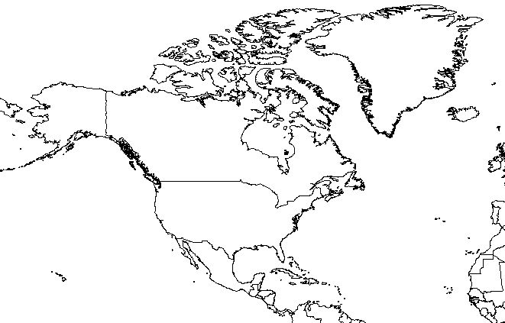

**Use the map above to complete the activity below.**

1. Write “**MT**” where you would find a Maritime Tropical air mass.

2. Write “**MP**” where you would find a Maritime Polar air mass.

3. Write “**CT**” where you would find a Continental Tropical air mass.

4. Write “**CP**” where you would find a Continental Polar Air mass.

**Climate Choices!**

For each description, decide which type of air mass would fit best. Use these words to help you: **maritime, continental, polar, tropical**

Jason chose to visit Death Valley, a desert in California. Summers are hot, usually more than 100°F and less than 5 inches of rain per year. What kind of air mass would be here?

____________________________

Janet and her friends are looking for a vacation spot to go skiing. They would need a place that is cold with a lot of snow. What kind of air mass would be here?

____________________________

C:\Users\KIPP STRIVE\AppData\Local\Microsoft\Windows\Temporary Internet Files\Content.IE5\059RKAEC\MC900290457[1].wmfC:\Users\KIPP STRIVE\AppData\Local\Microsoft\Windows\Temporary Internet Files\Content.IE5\33W594O6\MC900079257[1].wmf

Melissa live in Northern California, where there is a good bit of moisture during the winter. The temperatures are cool, around 40°F. What kind of air mass would be here?

____________________________

Explorers in the Amazon River Basin in South America get a rain shower every afternoon in a climate that is warm and humid all year. What kind of air mass would be here?

____________________________

C:\Users\KIPP STRIVE\AppData\Local\Microsoft\Windows\Temporary Internet Files\Content.IE5\DIF4QGLY\MC900250227[1].wmf

College kids choose to spend their Spring Break on the beaches near Miami, Florida. It’s hot and humid the entire time they are there. What kind of air mass would be here?

____________________________

The Chang family moves to a place where there is very little moisture and hot temperatures most of the year. What kind of air mass would be here?

____________________________





______________________________ _____________________________

______________________________ _____________________________

Feeling Spicy? Try this…

Earth and Science book. Pg. 27