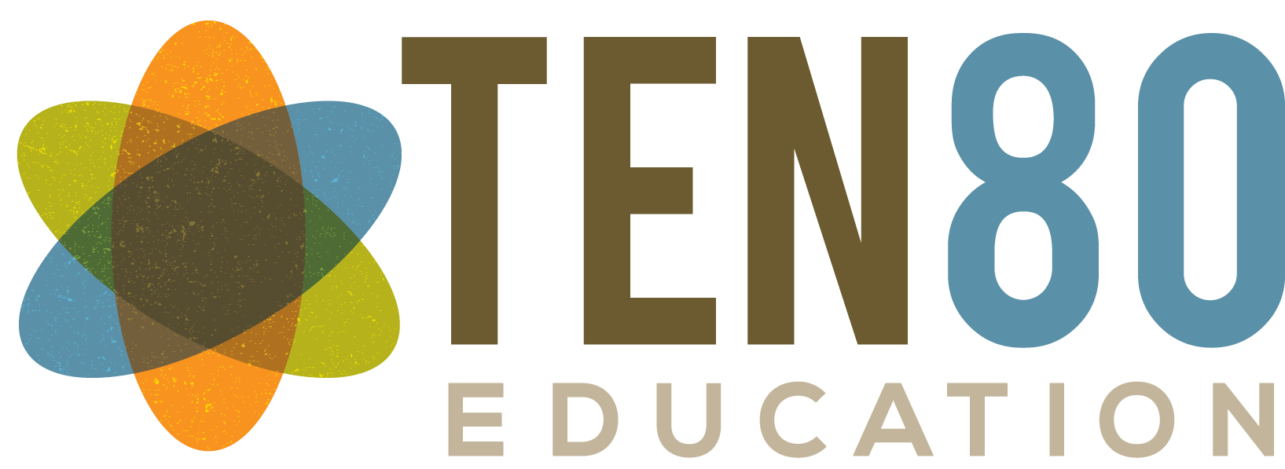
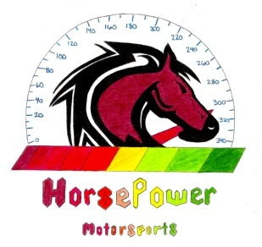
Contact: Stephanie Coggins
12840 Cheverly Drive
Huntersville, NC 28078
704.661.6813
stephaniem.coggins@cms.k12.nc.us
www.horsepowermotorsports.weebly.com

1st Annual Ten80 Horsepower Motorsports Golf Tournament

Date: Monday, April 27, 2015

Time: 11:00 am- Registration Begins
1:00 pm- Shotgun Start
Awards dinner following tournament

Location: River Run Country Club
18608 River Ford Drive
Davidson, NC 28036

Beneficiary: Ten80 Horsepower Motorsports National STEM League Competition Team

Title Sponsor $4,500
Your logo will be included on all tournament golf shirts and will be displayed at one hole on the golf course and at our registration table. You will also receive tickets for two foursomes to participate in the golf tournament and awards dinner that evening. You are encouraged to have representation at your designated hole. Your logo will be displayed on our marquis banner and hosted on our website: www.horsepowermotorsports.weebly.com

Presenting Sponsor $3,500
Your logo will be included on all tournament golf shirts and will be displayed at one hole on the golf course and at our registration table. You will also receive tickets for one foursome to participate in the golf tournament and awards dinner that evening. You are encouraged to have representation at your designated hole. Your logo will be displayed on our marquis banner and hosted on our website: www.horsepowermotorsports.weebly.com

Awards Dinner Sponsor $2,000
For hosting the awards dinner at River Run after the tournament, your logo will be displayed at one hole on the golf course and at our registration table. You will also receive tickets for one foursome to participate in the golf tournament and awards dinner. You are encouraged to have representation at your designated hole. Your logo will be displayed on our marquis banner and hosted on our website: www.horsepowermotorsports.weebly.com

Par 3 Sponsors $500 (2 spots available)
Your logo will be displayed on one par 3 hole on the golf course. Sponsors should set up on hole and are welcome to provide promotional items for your company. Your logo will also be hosted on our website: www.horsepowermotorsports.weebly.com

Corporate Tent Hole Sponsors $400
Your logo will be displayed on one hole on the golf course. Sponsors should set up on hole and provide snacks/drinks and are welcome to provide promotional items for your company. Your logo will also be hosted on our website: www.horsepowermotorsports.weebly.com

Hole Sponsors $100
Your logo will be displayed on one hole on the golf course, and your have the opportunity to provide samples or promotional coupons and materials in our gift bags. Your logo will be hosted on our website: www.horsepowermotorsports.weebly.com

Silent Auction/Raffle Sponsors
If you would like to contribute another way, we will be hosting a silent auction and a raffle. Items donated will either enter our silent auction or raffle during the tournament, and your logo will be hosted on our website: www.horsepowermotorsports.weebly.com

