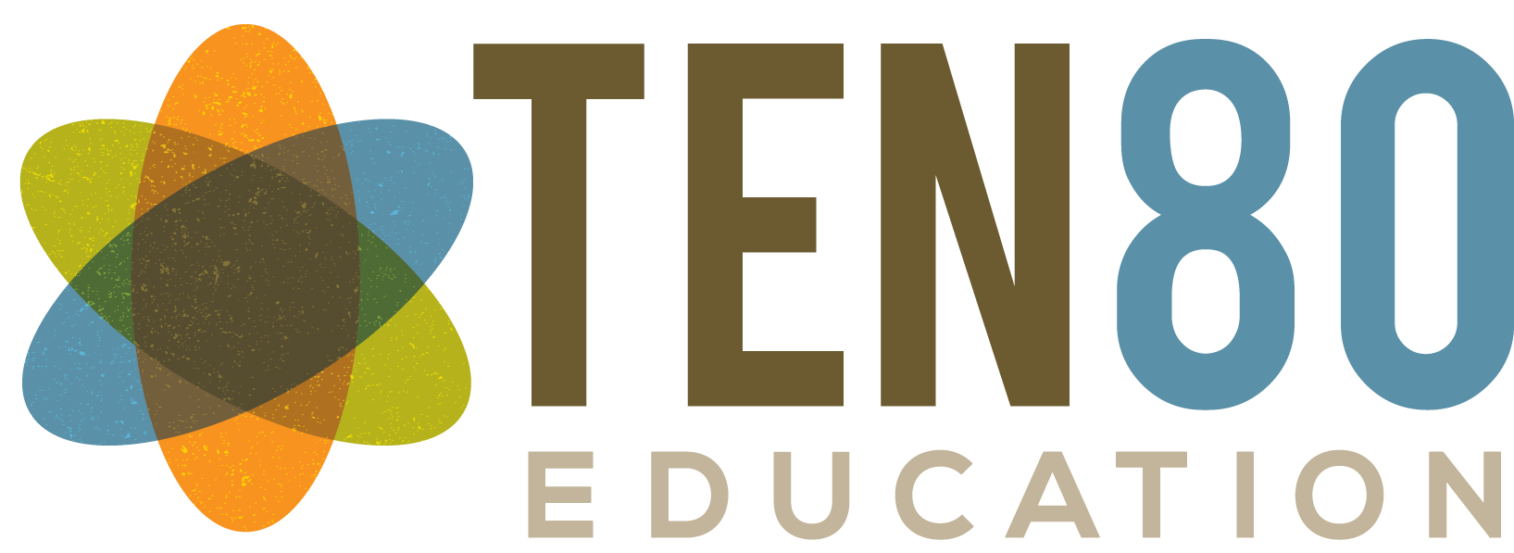
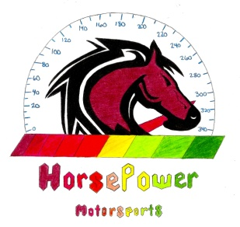

My name is Stephanie Coggins and I am a 7th grade science teacher at Bailey Middle School. I coach a STEM-based racing team through the Ten80 Education Foundation. The Ten80 program is a STEM (Science, Technology, Engineering, and Math) program that uses project-based learning to teach students the skills they need to succeed in the real world. My students competitively design, build, and race model cars, as well as use the business model to develop public relations, marketing, web design, and graphic design departments.

Our team, Horsepower Motorsports, was established in August 2013. I coach 20 6th, 7th, and 8th graders who compete on a national level against middle schools and high schools across the country. In our first year as a team, we placed first overall at Regionals and third overall at Nationals. My students are highly motivated, work cooperatively as a team, and I am so proud to coach them.

Our initial funding last year was through a few small grants and sponsorships, but this year and going forward we have much larger budgetary needs. We are hosting a charity golf tournament at River Run on Monday, April 27th and we are looking for businesses and organizations within our community who would be willing to sponsor us in a variety of ways. The attached sheet breaks down all of the different sponsorship opportunities that are available, as well as your return on your investment. Rather than simply ask for donations as we did last year, this golf tournament will provide you with key marketing in a variety of venues, and it also gives my students the opportunity to learn every facet of how to create and execute a fundraiser on such a large scale.

The Ten80 foundation has 501(c)3 status. Tax ID for your tax purposes will be available soon. My contact information is at the bottom of the page. Thank you so much for your time and consideration, and please do not hesitate to contact me with any questions you may have.

Sincerely,
Stephanie Coggins
Horsepower Motorsports Coach
Stephanie Coggins
12840 Cheverly Drive
Huntersville, NC 28078
704.661.6813
Stephaniem.coggins@cms.k12.nc.us

To learn more about our team, visit our team website: www.horsepowermotorsports.weebly.com
For more information about the Ten80 Foundation, visit: www.ten80foundation.org
For more information about the Ten80 Student Racing Challenge, visit: www.studentracingchallenge.com
Check out this video from the May 2012 competition: www.youtube.com/watch?v=_ADeckggsjg

