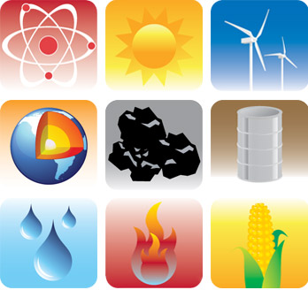
The Transfer
Of
Energy

Energy can be transferred from one system to another or to the environment in many ways:

1. Thermally- when a warmer object is in contact with a cooler one.
2. Mechanically- when two objects push or pull on each other over a distance.
3. Electrically- when an electrical source such as a battery is connected in a complete circuit to an electrical device.
4. By electromagnetic waves.

Electrical energy

Electrical energy can be produced from a variety of energy sources and can be transformed into almost any other form of energy.
- Batteries store and transfer energy to components in a circuit.
- The energy inside the battery comes from a chemical reaction.
- Electricity is important because we can use it to make things work.
  - For example: a bulb converts electrical energy to light energy, and a speaker converts electrical energy into sound energy.
- To produce electricity, a heat source is needed to create the conditions in which electrical currents form.
- The primary source of electrical energy is the heat that is generated by fossil fuels, water power, and wind power. The electric energy that is produced from these sources is a secondary source of energy.
- Lightning during storms is an example of natural electricity.
- Solar energy, water, and wind power are sources of green energy, meaning they don’t pollute the environment.

